**DAILY ONLINE ACTIVITIES SUMMARY**

|  |  |  |  |  |  |  |  |  |
| --- | --- | --- | --- | --- | --- | --- | --- | --- |
| **Date:** | **27-05-2020** | | | | | **Name:** | **Raksha S** | |
| **Sem & Sec** | **6th B** | | | | | **USN:** | **4AL17CS073** | |
| **Online Test Summary** | | | | | | | | |
| **Subject** | | **SSCD** | | | | | | |
| **Max. Marks** | | **30** | | **Score** | | | **20** | |
| **Certification Course Summary** | | | | | | | | |
| **Course** | **FullStack Webdvelopment** | | | | | | | |
| **Certificate Provider** | | | **Greatlearning** | | **Duration** | | | **45 days** |
| **Coding Challenges** | | | | | | | | |
| Problem Statement: 1. write a python to print all the integers that aren't divisible by either 2 or 3 and lie between 1 and 50.  2. write a python program to check if a number is a palindrome | | | | | | | | |
| **Status:** YES, Completed all Programs | | | | | | | | |
| **Uploaded the report in Github** | | | | | **YES** | | | |
| **If yes Repository name** | | | | | https://github.com/raksha05/[Daily-Status](https://github.com/raksha05/Daily-Status)/[Raksha 4AL17CS073](https://github.com/raksha05/Daily-Status/tree/master/Raksha%204AL17CS073)/**Raksha** | | | |
| **Uploaded the report in slack** | | | | | **YES** | | | |

Online Test Details:

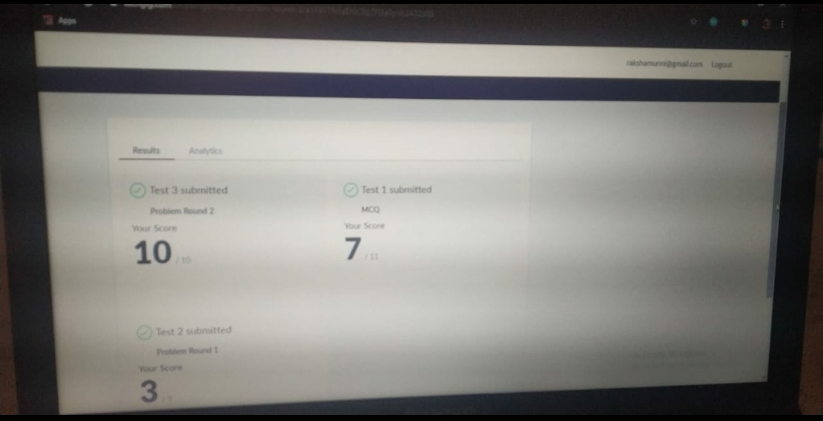

Scored 20 out of 30 in SSCD 2nd I.A test

Certification Course Details:

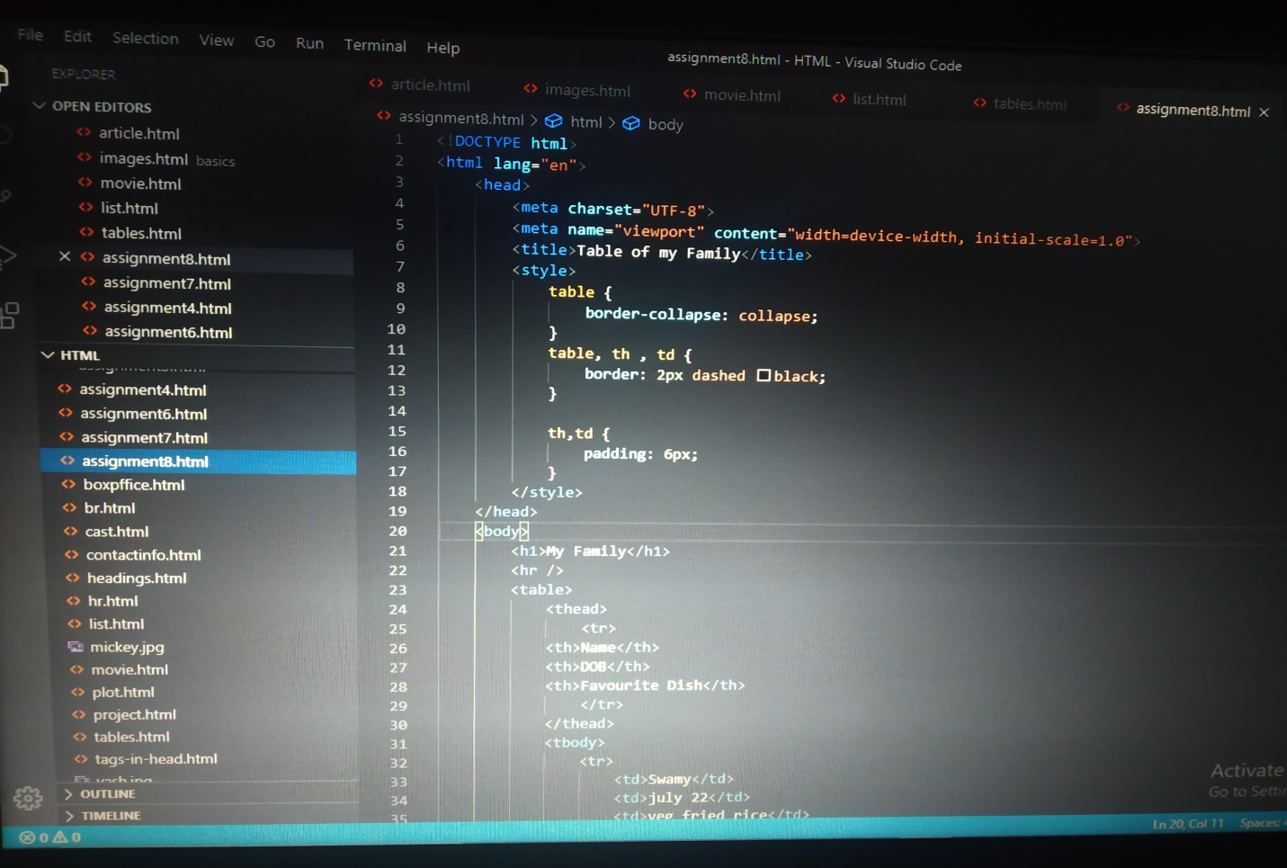

The above course is being taken up by me is based on Fullstack Webdevelopment. Today in online course I studied abouthow to create dashed table and solid table.And few assignments were given. The details of the course and certificate provider are mentioned in the above form.

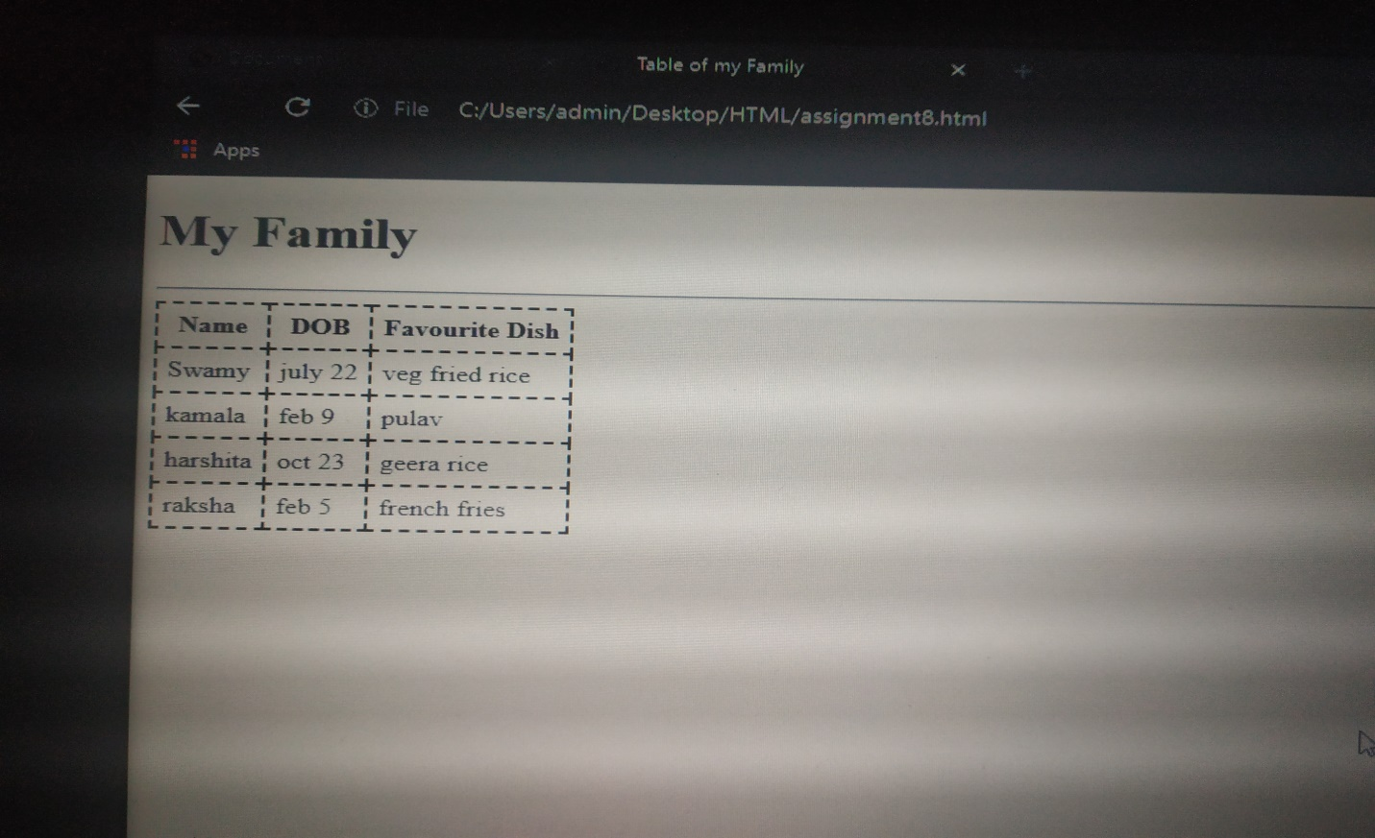

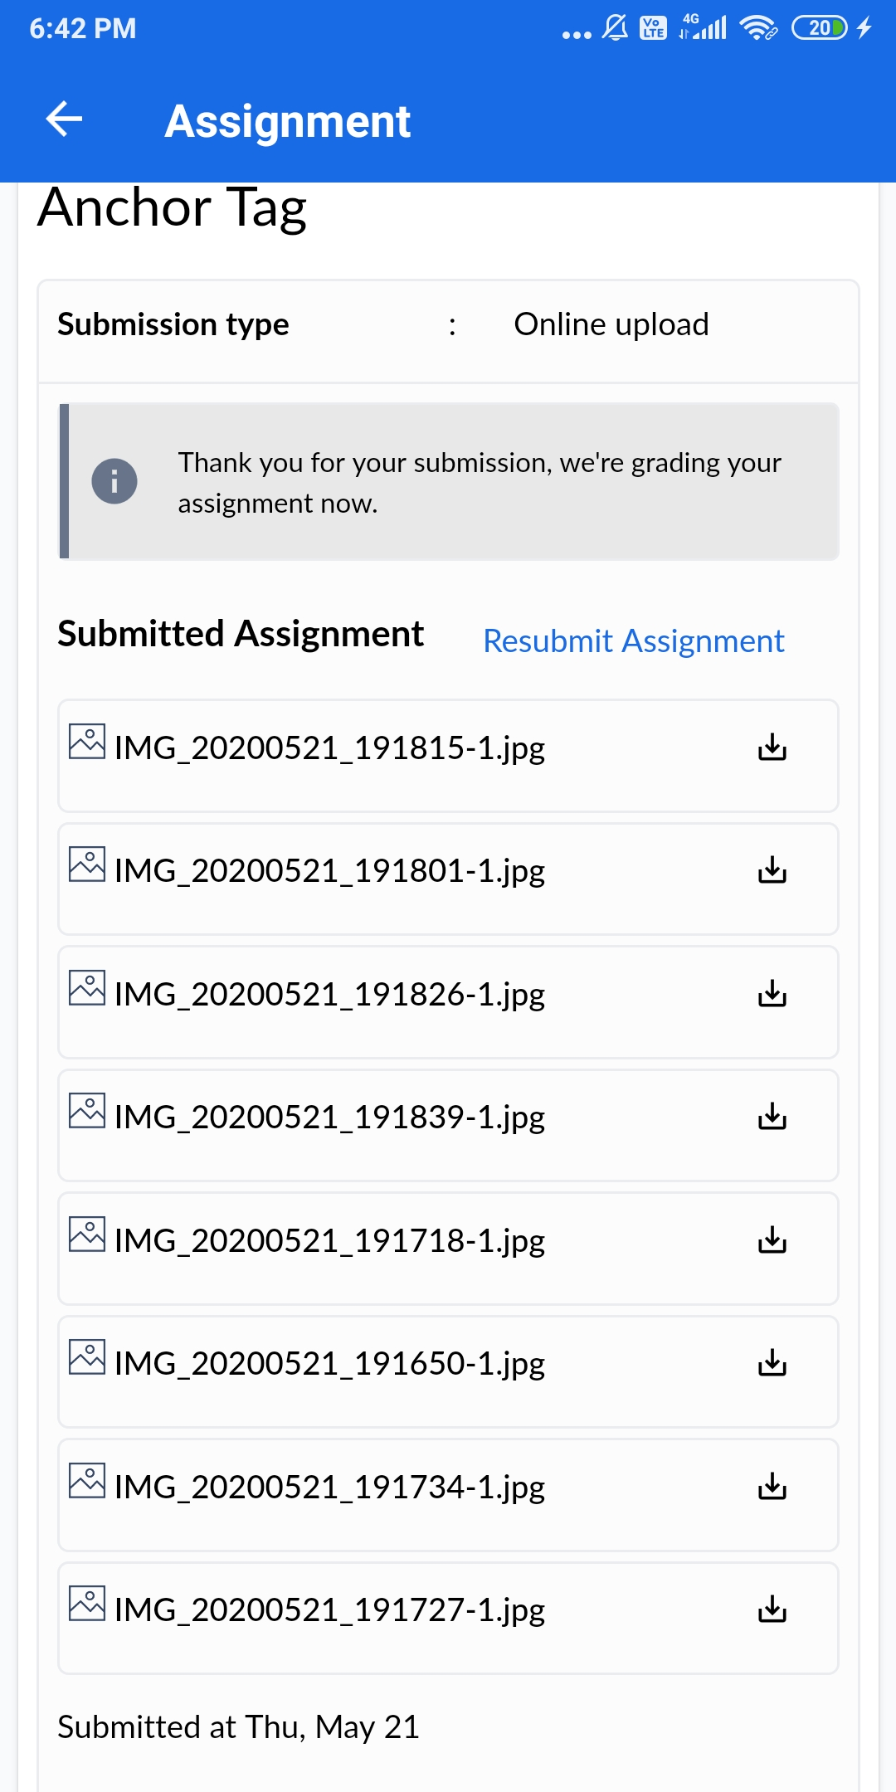

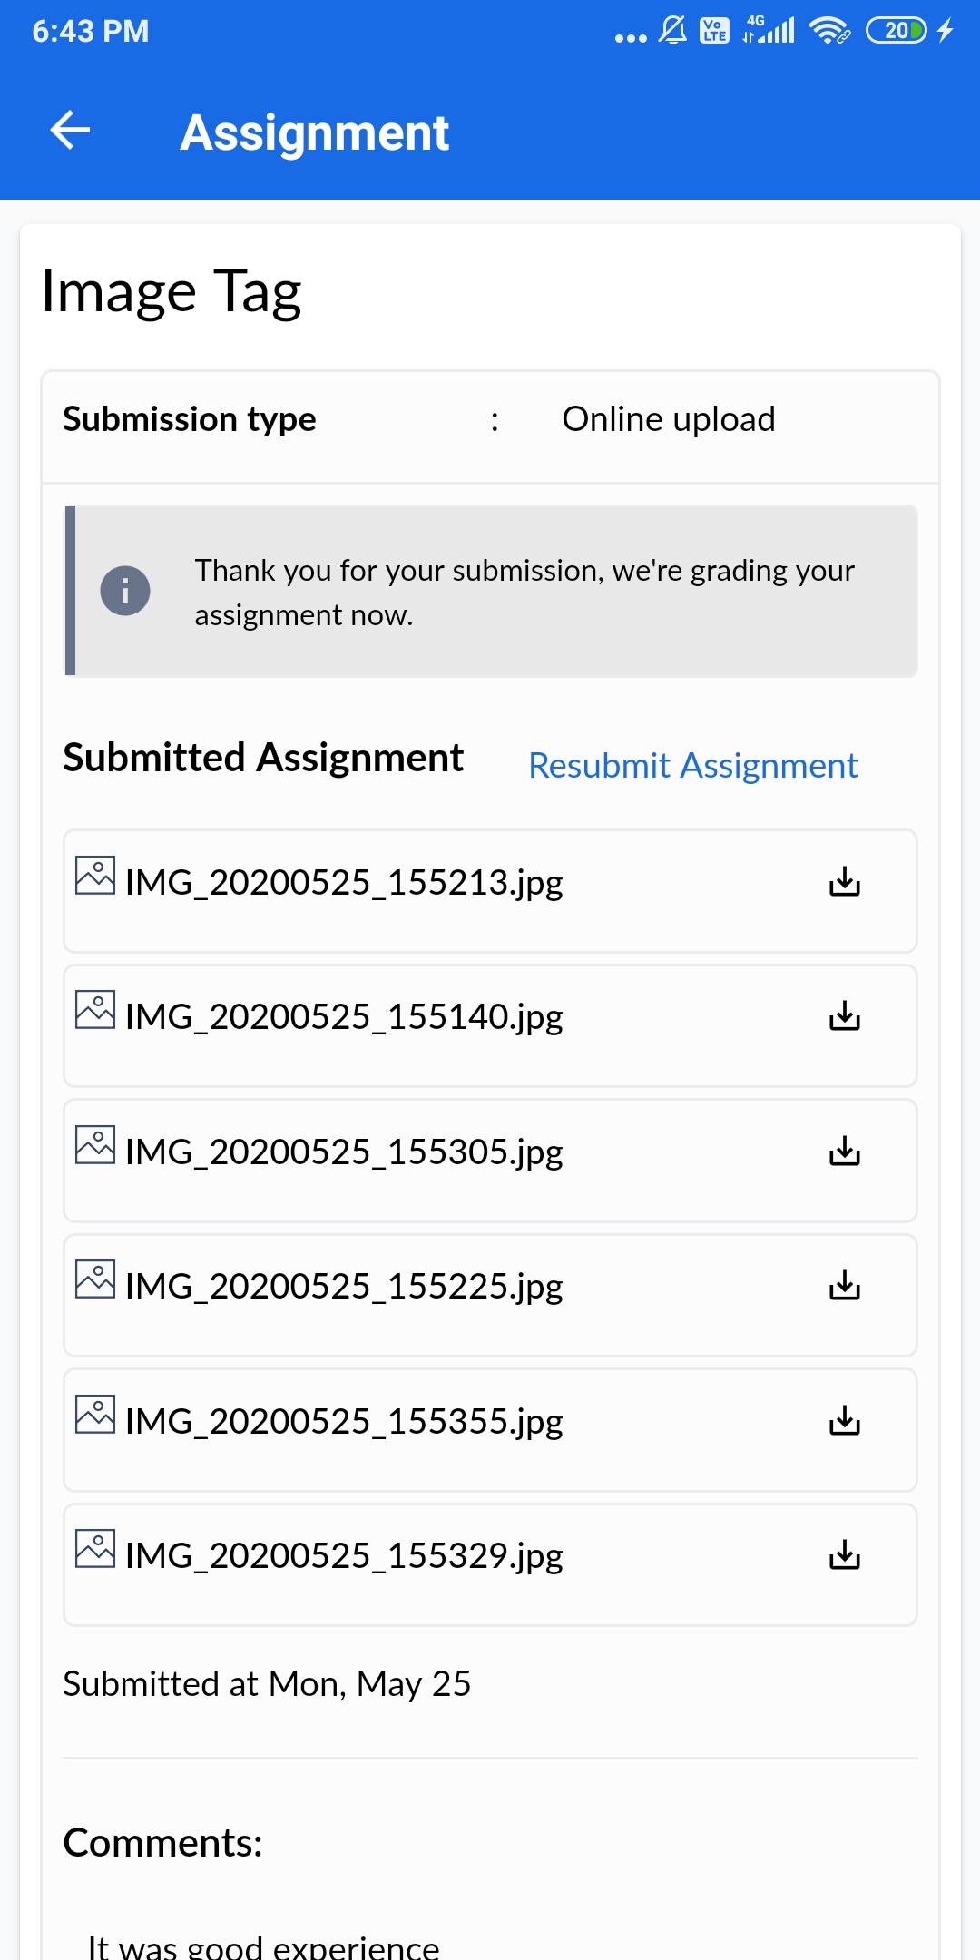

Above were the assignments given to me to create my favourite movie website which includes cast,plot and box office webpage sections and to include images,when I click one image ,it should take me to that particular website.As I can’t upload the video in a word file I will upload it in my certification folder.

Coding Challenges Details:

Program1:

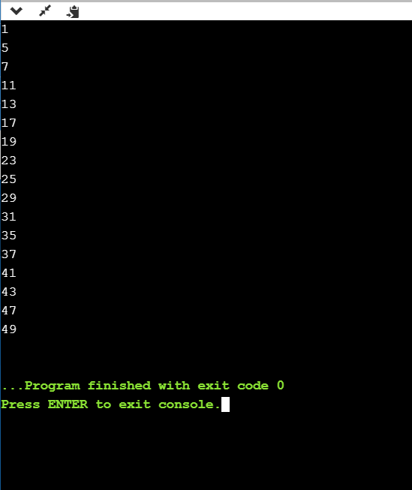

Program2:

